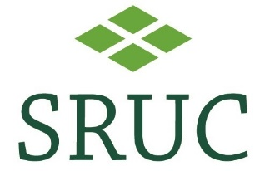
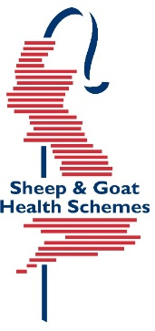

Premium Sheep & Goat Health Scheme Declaration by Owner and Veterinary Surgeon

Please complete and return the attached form to accompany samples received _________________. A full report cannot be issued without this.

Test ref:

Client account number:

Declaration by Owner and Veterinary Surgeon

I agree to abide by the rules and conditions of membership. All information provided is correct at the time of recording.

Signed:…………………………………………………….. Owner/Manager

Name:……………………………………………………… Date:…………………………..

1.I have explained the rules of the scheme to my client who, to the best of my knowledge, is complying with the rules and conditions of PSGHS.

2.I have blood sampled, according to the rules, the appropriate number of animals.

Signed:……………………………………………………… MRCVS

Name:……………………………………………………….. Date:…………………………….

