# SRUC 2023-24 Performance Indicators for Further Education Level Provision

The Scottish Funding Council (SFC) reports on an annual basis on each college’s learner performance across Scotland. SRUC is a designated Higher Education Institution providing both Further Education and Higher Education. This report focuses only on our Further Education provision, which means all courses up to and including SCQF Level 6. The information provided by the SFC enables us to review our academic success on an annual basis and allows us to benchmark ourselves nationally against the rest of the Scottish College sector.

In Academic year 2023-24 SRUC have continued to proactively implement SRUC’s Learning and Teaching Enhancement Strategy 2020-2025, which focuses on delivering programmes in a blended manner that is best suited to the level of the students and the nature of the subject area, combining face to face delivery with online learning, technologies and teaching approaches.

Against a challenging economic background for many, and with increasing levels of students with support needs, there has been a continued improvement in success rates in the five years reported. That aside, as an institution that delivers predominantly vocational programmes, our students are eminently employable, and we are ﬁnding that some students are leaving their studies early to take up positions within the industries we serve.

It is within this context that we are now in a position to publish our 2023-24 data on our website in the form of various charts. To aid your reading of the results the highlights can be summarised as follows:

# Outcomes for FE on recognised qualiﬁcations (full-time)

SRUC has seen an increase in success rates for its students at the Further Education Level with 70.4% of full-time students who enrolled with us successfully achieving their qualiﬁcation (Chart 1.). This is an increase of 1.1% from 69.3% in 2022/23, and the highest success rate in the five years reported.

# Outcomes for FE on recognised qualiﬁcations (part-time)

Part time success rates for students on recognised qualiﬁcations are stable with 85.8% achieved in 2022/23 to 85.5% in 2023/24 (Chart 2a). Partial success reduced from 11.2 % in 2022/23 to 10.4% in 2023/24. SRUC are pleased that the vast majority of our part time students continue to successfully achieve their programmes.

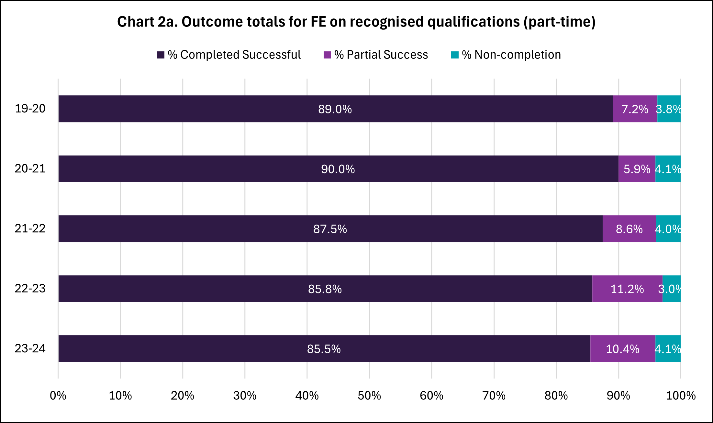

# 3. Enrolments by key group on courses lasting 160 hours or more

# Chart 11 indicated the success rates of key groups of students. The following can be noted:

* 1. 74.2% of students who came to us from the 20% most deprived data zone areas successfully achieved their qualiﬁcation as compared to 64.2% in 2022/23
  2. 72.5% of students with a recognised disability successfully passed their

qualiﬁcation as compared to 64.6% in 2022/23

SRUC’s outcomes in this area cannot be compared to sector benchmark as the sector data includes both FE and HE students in these measures, whereas SRUC data is restricted to FE students only.

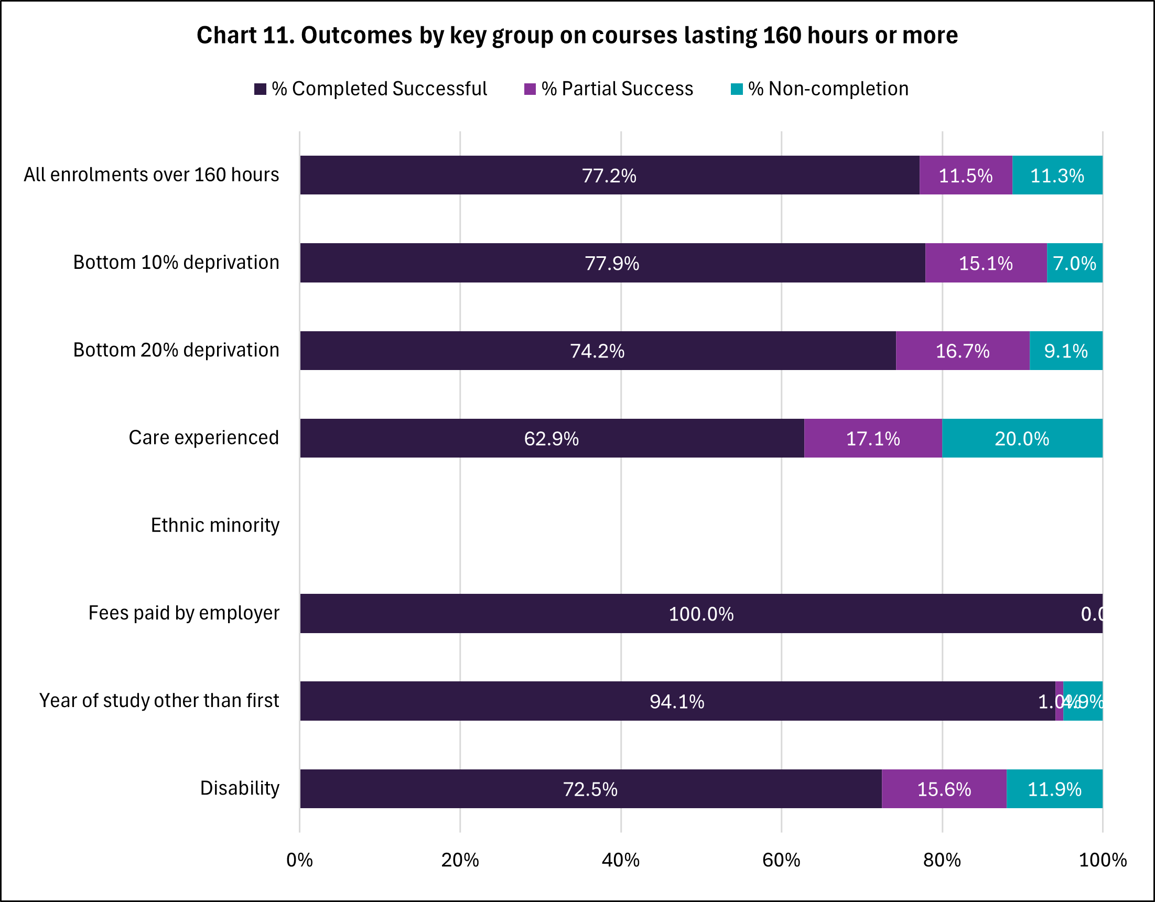

SRUC as the National Land-based College for Scotland is committed to providing high quality education and training at its ﬁve campuses, to those on distance learning courses and to those undertaking Modern Apprenticeships to ensure our further education provision is accessible to all and can provide an important stepping stone both into employment and onto Higher Education.

These performance indicators for Further Education courses provide us with important outcomes for us to measure our success and improve our performance where appropriate year-on-year. To enable us to do so, we will be analysing the data in detail both against sector averages and where relevant on a course by course basis to ensure we continually strive to enhance and improve the quality of our learning and teaching.

Further details about College Performance Indicators can be accessed via the [Scottish Funding Council website.](https://www.sfc.ac.uk/)

*In previous publications, early withdrawals (i.e. students withdrawing from their course before the funding qualifying date) were included in the calculation of the College Performance Indicators. Following* [*stakeholder consultation*](https://www.sfc.ac.uk/publications/report-on-the-consultation-on-changes-to-the-college-performance-indicators/)*, for the 2023-24 reports early withdrawals have been excluded from the performance indicators (‘EW excluded’ report) and instead are reported separately (‘EW only’ report). To enable comparability between academic years, this exclusion has been applied to the data for previous years, and therefore the figures presented in the current year’s reports will not match previous publications*